Mental strategies – Addition and subtraction
Helpful information
Mental computation strategies
It is critical that students develop trusted, efficient and flexible methods for adding and subtracting whole numbers and decimals. Students’ ability to solve addition and subtraction problems confidently and efficiently will often rely on their use of a mental strategy.
Students need to develop fluency with mental strategies, prior to the introduction of formal written methods. Students are at risk of developing misconceptions in computation when formal written methods are introduced before they are confident in solving problems mentally. The focus of computation lessons in the early Years (at least P–2) is on developing mental strategies for adding and subtracting.
A feature of mental computation is that a problem can often be worked out in several different ways. The most appropriate strategy will depend on the numbers involved, the context of the problem, the age of the user and the range of methods that they are confident with. Students with a deep and flexible understanding of the relationship between addition and subtraction, whole number place value, partitioning and basic facts are well-equipped to develop efficient personal strategies.
There are numerous mental strategies for addition and subtraction. However, in different systems worldwide, there is general agreement on three methods. Curriculum into the Classroom will refer to these strategies as:
- Jump
- Split
- Compensate.
Teaching mental computation
Mental computation strategies should to be taught explicitly, however the goal is for students to develop preferred personal strategies, suited to different number contexts.
In teaching mental computation strategies, the following principles are a sound guide for teachers:
- Commit regular time to teaching mental computation strategies.
- Provide practise time with frequent opportunities for children to choose and use familiar strategies.
- Encourage the use of structured materials and models to represent mental strategies.
- Model the use of informal jottings to support mental computation. Encourage students’ use of jottings as they calculate mentally.
- Provide opportunities for students to discuss and explain their methods and strategies.
- Delay the introduction of formal written methods (algorithms) until students can confidently demonstrate the use of appropriate mental strategies.
Adding and subtracting with the JUMP strategy
The Jump strategy requires the user to:
- keep one number unchanged
- partition (break up) the other number
- add or subtract the parts.
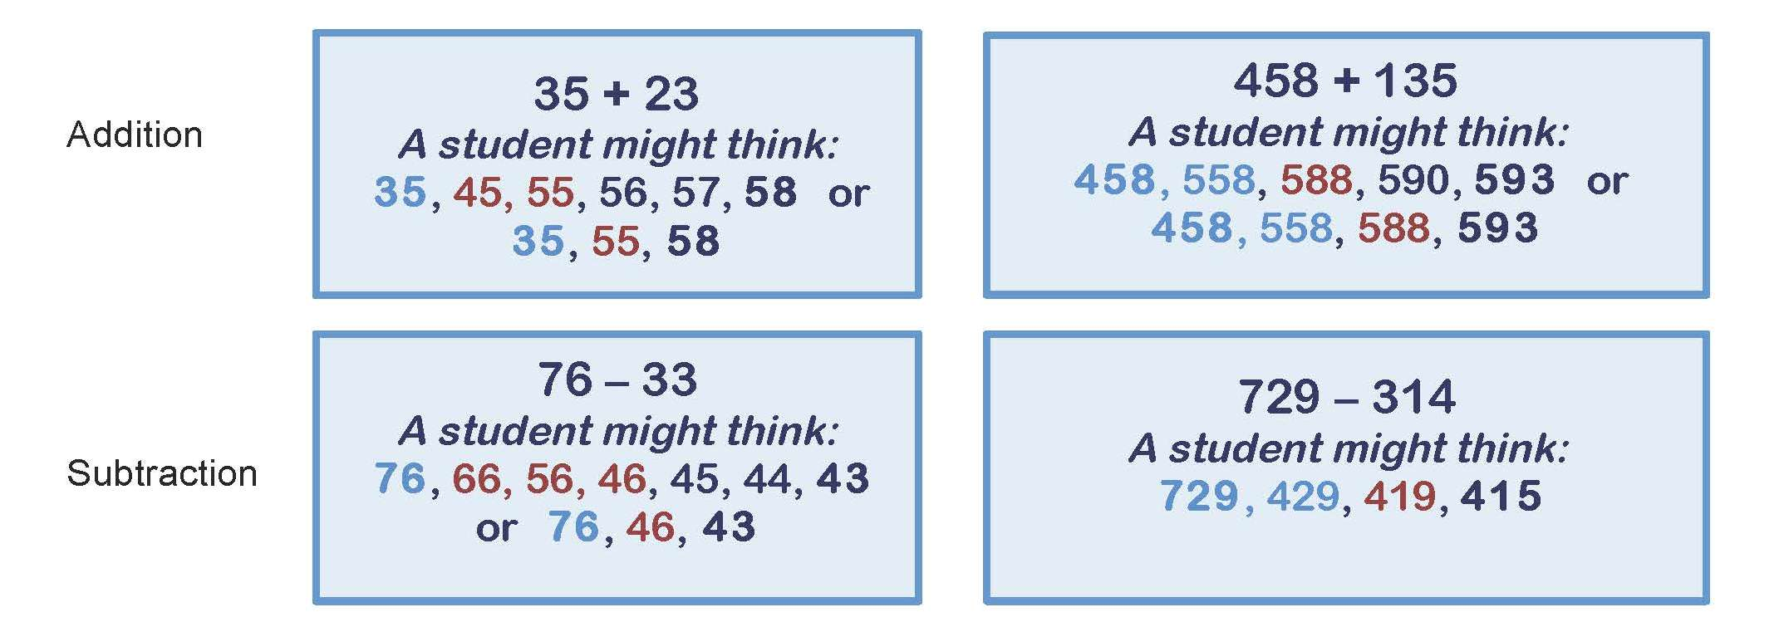
The Jump strategy can be represented with materials and visual models. In particular, hundred boards and empty number lines can be helpful in developing understanding.
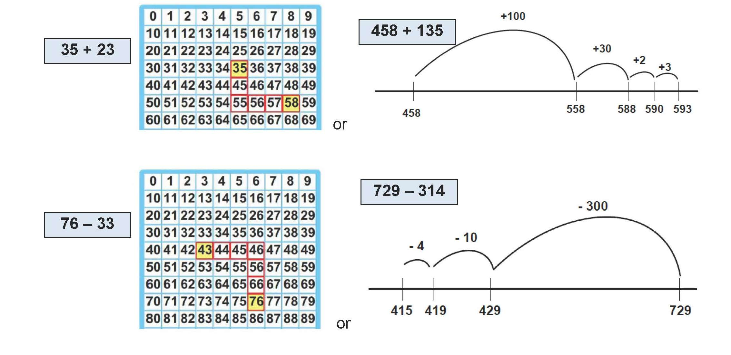
Students’ informal recording of the Jump strategy may resemble the following:
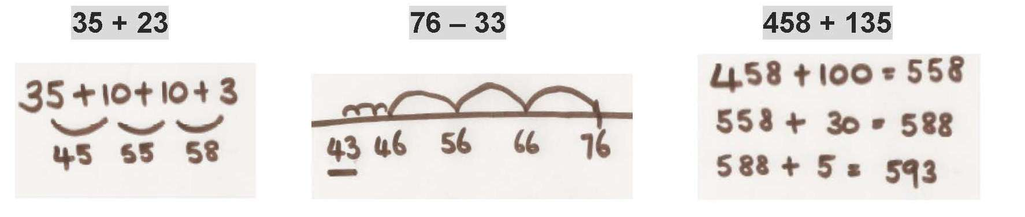

Adding and subtracting with the SPLIT strategy
The Split strategy requires the user to:
- partition (break up) both numbers
- add or subtract the place value parts
- recombine the added parts to make the sum.
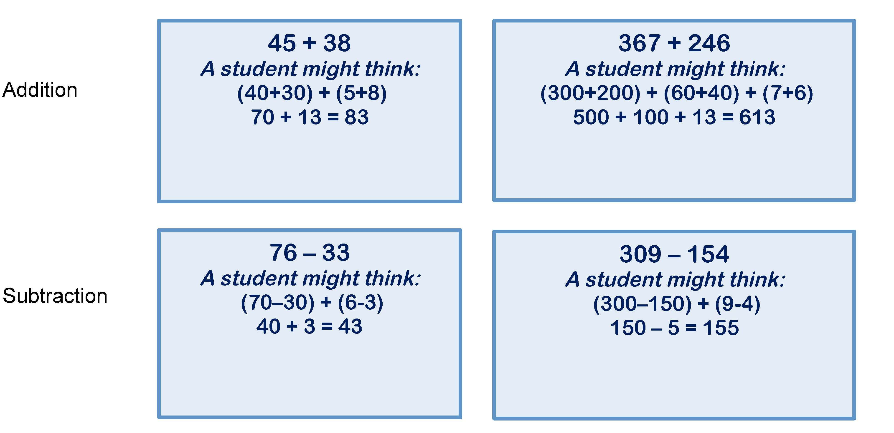
The Split strategy relies heavily on students’ flexible place value understanding. It can be represented with materials and visual models, including base ten blocks and place value charts.
Students’ informal recording of the Split strategy may resemble the following:
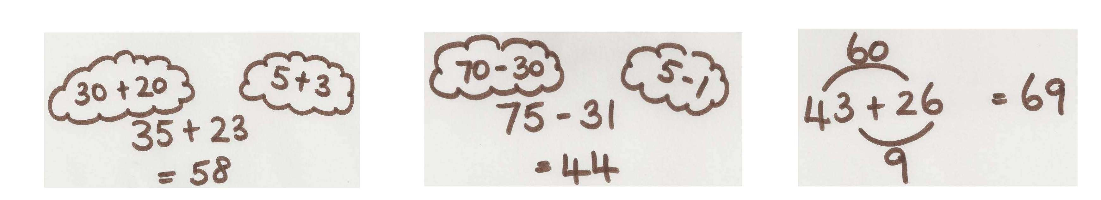
Typically, users of the Split strategy will partition numbers and add or subtract mentally from the larger place (from the left). This is contrary to the formal written algorithm for addition and subtraction used widely in Queensland schools.

Adding and subtracting with the COMPENSATE strategy
The Compensate strategy requires the user to:
- adjust one number (building up or building down)
- add or subtract the parts
- adjust the sum (or difference).
It is most common to adjust one number to a benchmark number, e.g. multiples of 10, 100 or 1000. However, as students become more fluent with the strategy, they might adjust to other compatible numbers, e.g. 25, 75.
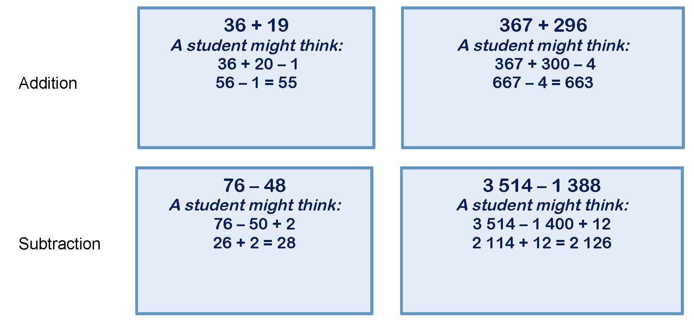
The Compensate strategy can be represented with materials and visual models. In particular, hundred boards and empty number lines can be helpful in developing understanding.
Students’ informal recording of the Compensate strategy may resemble the following:
